MILESTONE 4: Data Visualization
Data visualization is the process of creating graphical representations of data to help people understand and explore the information. The goal of data visualization is to make complex data sets more accessible, intuitive, and easier to interpret. By using visual elements such as charts, graphs, and maps, data visualizations can help people quickly identify patterns, trends, and outliers in the data.

No.of Unique Visualizations
Using the given dataset, several unique visualizations can be created to analyze the dietary habits, nutritional intake, and health outcomes of college students. These visualizations include bar charts, line charts, heat maps, scatter plots, pie charts, and maps. These can be used to compare performance, track changes over time, show distribution, identify relationships, breakdown nutritional intake, provide demographic insights, inform resource allocation, and conduct geographical analysis. By leveraging these diverse visualizations, stakeholders can gain comprehensive insights into the dietary choices and health of college students, enabling data-driven decisions to promote better nutrition and overall well-being.
MILESTONE 5 :visualizations
Explanation link for all visualizations: https://drive.google.com/file/d/1wZSY11xLTglUn50D9Isc6NU2CkEiBSQz/view?usp=sharing

Activity 1.1: Countries per Region

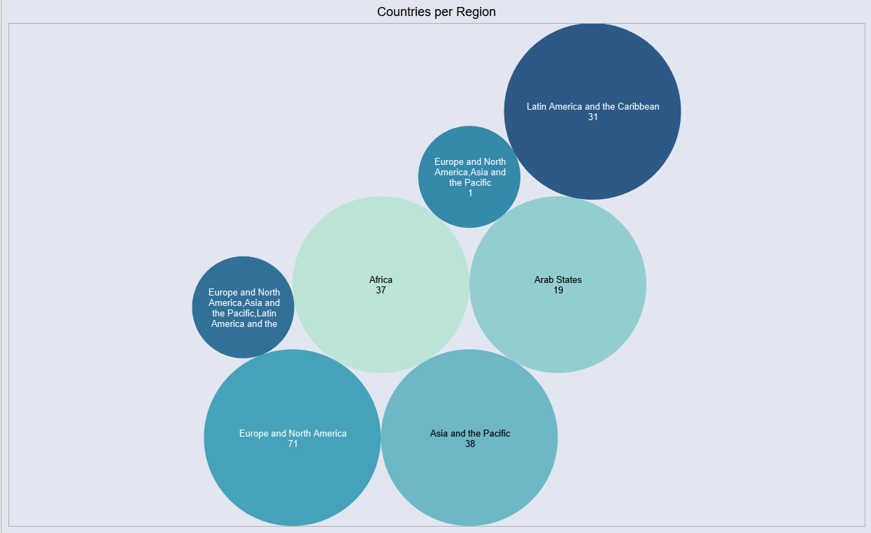

Activity 1.2: Top 10 regions by area
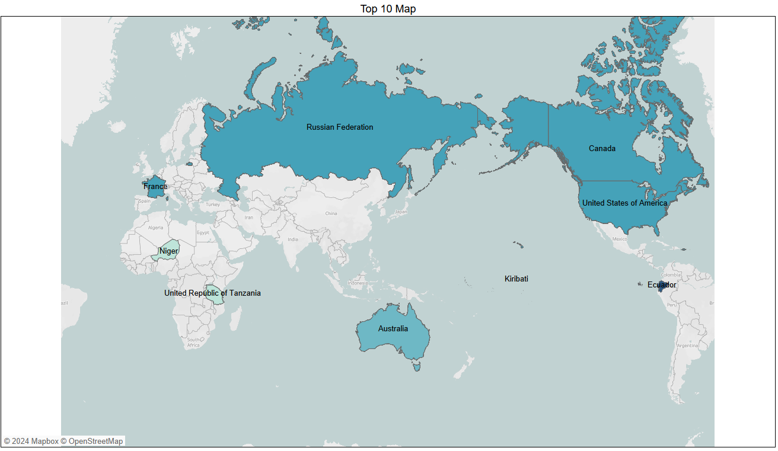

Activity 1.3: Regions by Heritage ended
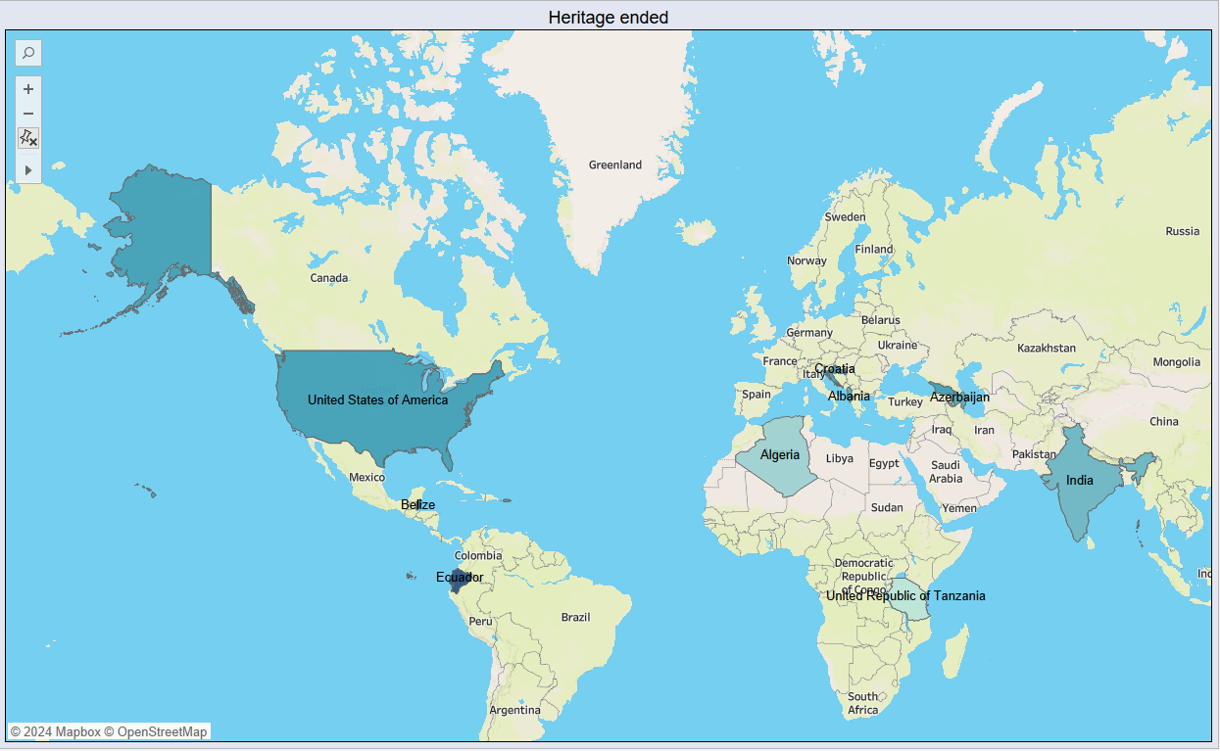

Activity 1.4 : Top 10 Danger Sites prone to Extinction
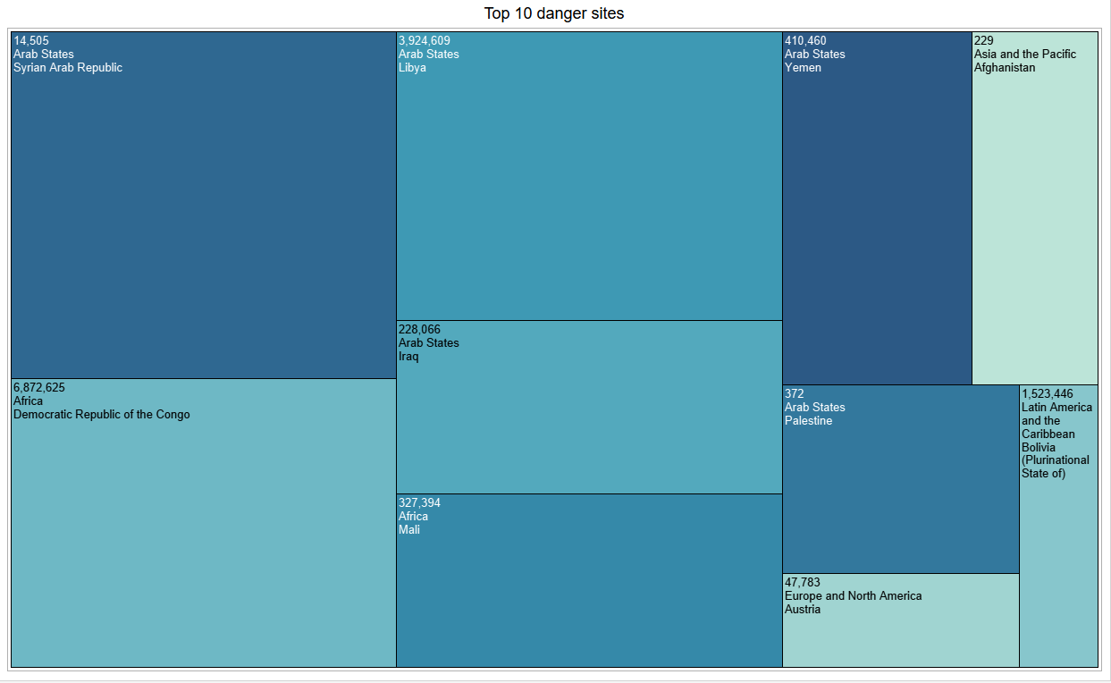
Activity 1.5 : Year Forecasting of Heritages
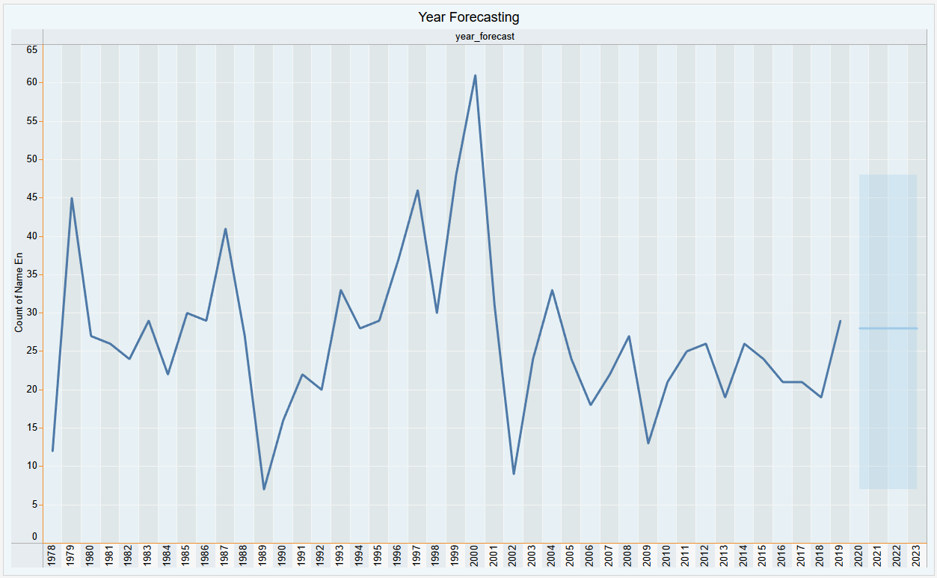

Activity 1.6 : Categories by sites count
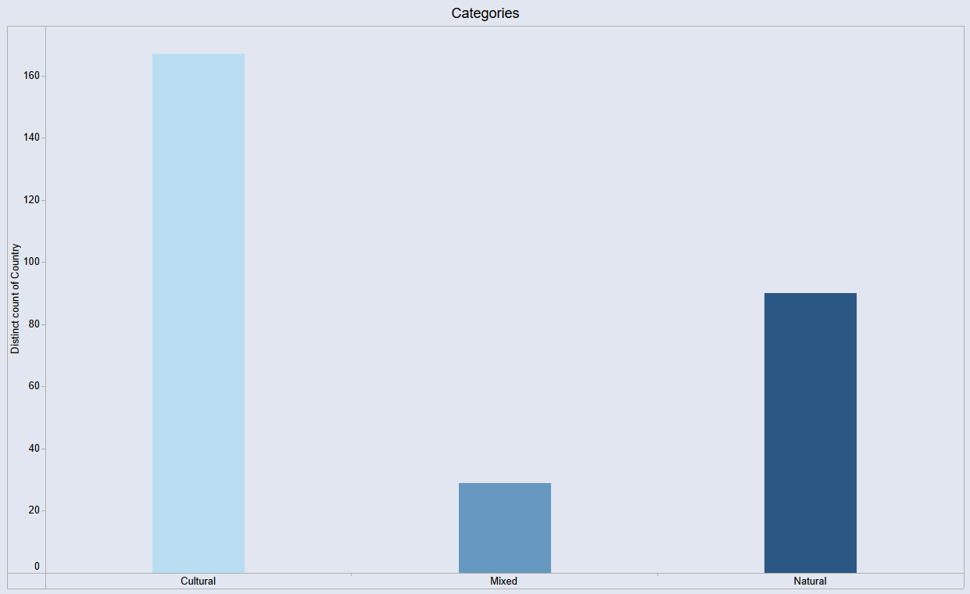

Activity 1.7 : Site Count per Region
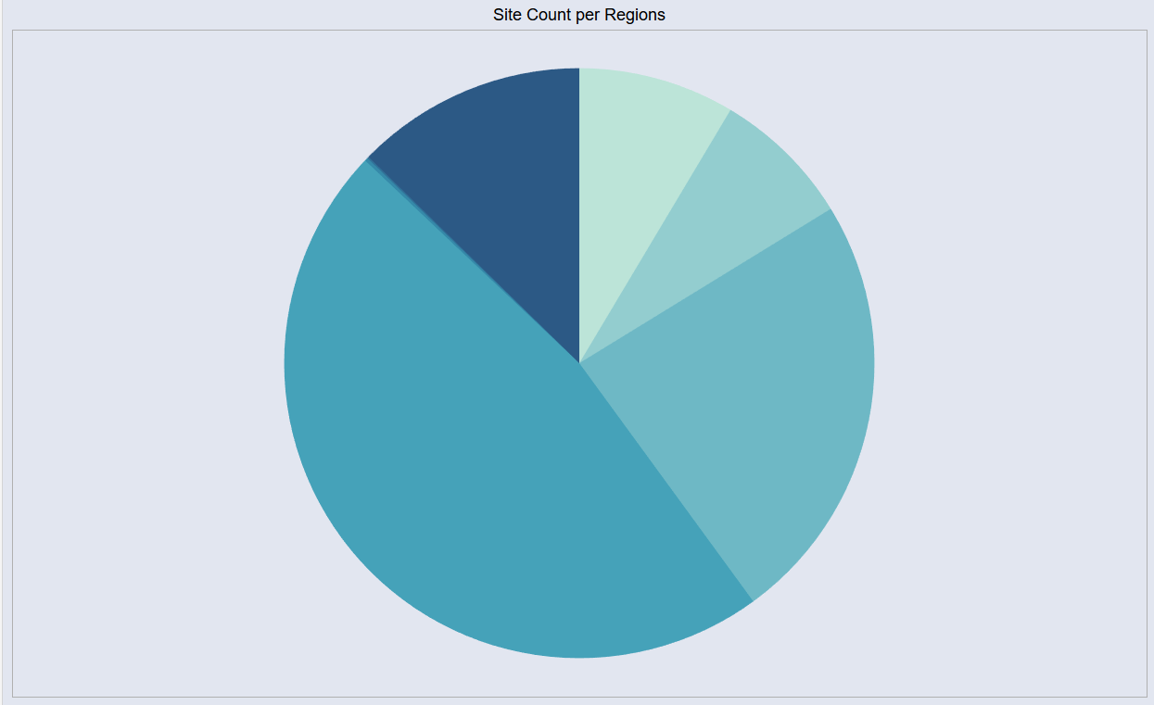

Activity 1.8 : Analysis of Danger sites and Area of heritages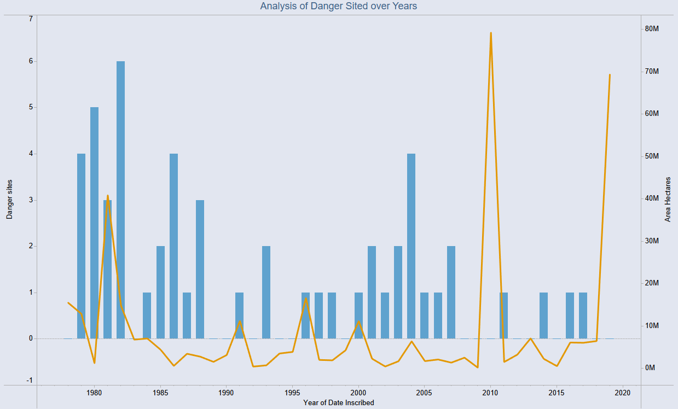
Note: All the above visualizations were explained in the link mentioned above.

